**Chino Valley Unified**

**School District**

**Activities to Build Partnerships**

* **PFA Involvement**
* **Grade Level Activities**
* **School Site Council**
* **English Learner Advisory Committee**
* **Title I Meeting**
* **Mileage Club**
* **21st Century Parent Night**
* **Partnership for Learning Network**
* **Parent Advisory Committee**
* **Fall Family Festival**
* **Picture Person Program**
* **Back to School Night/Open House**
* **Awards Ceremonies**
* **Science Fair**

**Volunteering Opportunities**

If you would like to *volunteer, participate* in, and/or *observe a classroom please contact the school.*

**What is a School-Parent Compact?**

A *School-Parent Compact for Achievement* is an agreement that parents, students and teachers develop together. It explains how parents and teachers will work together to make sure all our students reach or exceed grade-level standards.

Effective compacts:

* **Link** to goals of the school's single plan for student achievement
* **Focus** on student learning skills
* **Describe** how teachers will help students develop those skills using high-quality curriculum and effective instruction in a supportive learning environment
* **Share** strategies parents can use at home
* **Explain** how teachers and parents will communicate about student progress
* **Describe** opportunities for parents to volunteer, observe, and participate in the classroom

**School-Parent Compact Parent Participation**

**SCHOOL-PARENT COMPACT**

**for**

**STUDENT ACHIEVEMENT**

**2017-2018**

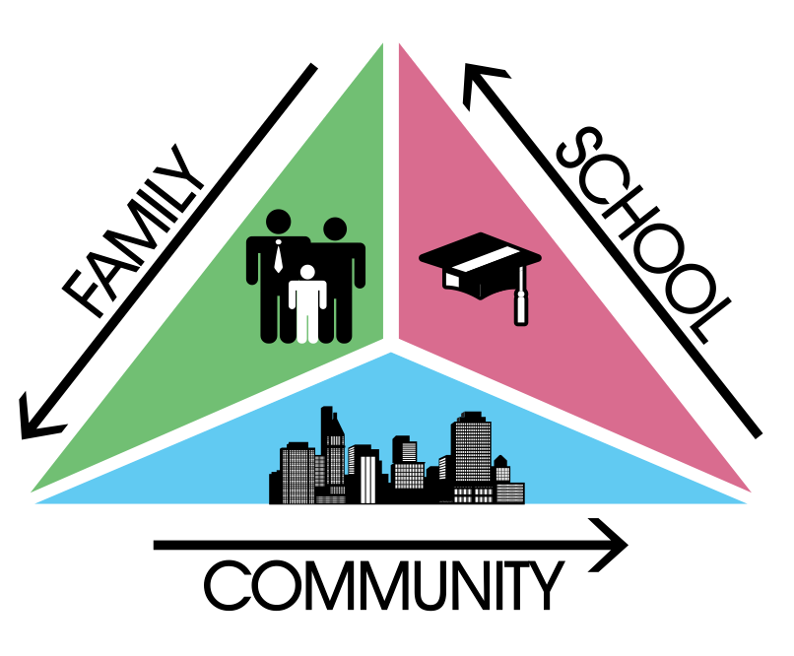

**Third Grade**

Lyle S. Briggs K-8 School

11880 Roswell Avenue

Chino, CA 91710

(909) 628-6497

**www.chino.k12.ca.us/briggs**

**Tell me and I forget. Teach me and I remember. Involve me and I learn.  
 ----Benjamin Franklin**

**School-Parent Compact**



**Communication about Student Learning**

Our school is committed to regular two-way communication with families about their children’s learning. Some of the ways parents and teachers communicate all year are:

* + School Website/Teachers’ Website
  + Class Dojo
  + School Messenger (Phone Blasts)
  + Aeries Communication
  + Aeries Parent Portal
  + School Marquee
  + Weekly homework folder/School Agendas
  + Remind
  + Email
  + Parent-teacher conferences
  + Phone calls

**www.chino.k12.ca.us/briggs**

**DISTRICT PARENT RESOURCES**

**Family Engagement Center**

**Adult School, Room 25**

**12970 Third St. Chino, CA 91710**

***Transition Workshops***

***Special Education Support Meetings***

***English Learner Parent Academy***

**Parent and School Partnership Link:**

**http://www.chino.k12.ca.us/Page/8882**

**carol_sweat@chino.k12.ca.us**

**909 628-1201 ext 5601**

**(Spanish) 909 628-1201 ext 5602**

M

**School-Parent Compact**

**Teachers, Parents, Students Shared Responsibility for Learning**

**At Home**

**Activities at home to support what my child is doing at school:**

**Academic Goal**

* Encourage your child to practice all assigned 3rd grade computer programs at home
* Practice with your child speaking and writing in complete sentences when completing homework
* Encourage daily reading at the appropriate level at home
* Review new vocabulary at home and use as part of your daily conversations (math too!)
* Sign up for all forms of communications (Aeries, class and school websites, Class Dojo, Accelerated Reader)
* Check your child’s homework on a daily basis, check and sign agendas
* Have your child on a binder system that has folders by subject. Make sure they are organized and cleaned out weekly at home
* Join PFA and participate in school events
* Assign your child jobs at home

Student Goal(s): I will …

.If you would like to volunteer, participate in, and/or observe a classroom, don’t hesitate to ask!

**In the Classroom**

**In the classroom, 3rd grade teachers will focus effective instruction and these high-impact strategies to support school goals:**

**Academic Goal**

* Log on to Class Links and the technology apps
* Match curriculum skills with Jiji Math Program
* ELA/Wonders Units will include technology-based components and projects
* Provide a variety of PBL/STEAM/PLTW activities
* Store and share work in Office 365 and Google Drive accounts

**Non-Academic Goal**

* Deliver Second Step Lessons
* Use a variety of forms of technology as a part communication tool
* Post classroom and school wide expectations
* Use of classroom agenda and binder system for accountability
* Assign students jobs in the classroom

**English Learner Goal**

* Implement 30 minutes of designated ELD time (writing, listening, and speaking)
* Encourage students to answer in complete sentences
* Use anchor charts, Thinking Maps, and binder notes to introduce concepts and skills
* Frontload academic vocabulary instruction

* **Student Learning Activities**
* ***Activities students will do to support their learning:*  Students will utilize the curriculum provided by the district. They will collaborate with their peers, utilize thinking maps and technology to support their learning.**

**District Goals - Local Control Accountability Plan (LCAP)**

All students are provided a high-quality teaching and learning environment.

Staff, parents, families, and students are connected and engaged at their school to ensure student success.

All students are prepared for college and career beyond graduation.

**School Goals**

**Academic**: Provide students opportunities to engage in the CCSS and next generation Science Standards through Project-Based Learning and STEAM activities to enable student multiple means of expressing proficiency through cross-curricular delivery of instruction.

**Non-Academic**: Teachers will effectively implement the Positive Behavior Intervention and Supports System, PBIS, (Tier1) in all school settings grounded in the School Wide Expectations of Being Respectful, Responsible, and Safe.

**English Learner**: English Learners (ELs) will increase one proficiency level, as evidenced by performance on the annual ELPAC, through the use of EL strategies and instructional technology.

*Our school provides high quality curriculum and instruction in supportive and effective classroom environments to enable students to meet state academic standards. We support our students and work hard to provide a welcoming, safe school environment.*

**Our Goals for**

**Student Achievement**